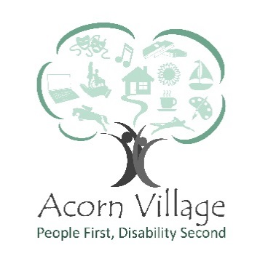
Role Description – Charity Shop Volunteer
___________________________________________________________________________

Reports to: Retail Coordinator
Responsible for: Helping with the day to day running of the Charity Shops
Location: Acorn Village, Clacton Road, Mistley, Manningtree, Essex, CO11 2NJ or High street Manningtree
Role Purpose: Work alongside other volunteers to maximise sales and to provide a robust income stream for the Organisation
___________________________________________________________________________
Key Responsibilities
- Greeting customers in a polite manner
- To serve customers using the electronic till system
- To ensure the shop remains clean, tidy and is well presented
- To assist with shop/window displays
- Regular restocking of donated items
- Organising occasional sale offers
- Work with other volunteers to ensure the regular flow of new stock to and from
  - Manningtree shop
  - Onsite shop
  - Book store
- Promote the Charity
- Understanding and adhering to the health and safety regulations of the organisation.
- Completing relevant training
- Identify hazards, assess risks and report incidents as required

Special Features of the Role
- Work as part of the Communications and Income Generation Team to assist in achieving its financial goals

Personal Development
- All volunteers are encouraged to contribute to identifying and meeting their own role-related development needs. This will be achieved through a variety of processes including supervisions and team meetings
- Volunteers must attend statutory and mandatory training as required by the Organisation and/or our professional bodies

Key skills, experience and knowledge
- An interest in the charity shops and an enthusiasm for raising money through its work
- Good communication and interpersonal skills and a positive, can do attitude
- Appreciation for quality control standards and processes
- Creativity and willingness to learn
- Adaptable and flexible
- Keen eye to detail
- Able to plan and organise workload
- Able to work on own initiative and/or as part of a team
- Passion and drive to achieve results through increased sales
- Ability to maintain an awareness of current fashion trends and brands
- Good understanding of equality & diversity
- Willingness to undertake mandatory training

Training requirements
- Induction
- Health & Safety
- Fire safety
- Moving and Handling

What you will gain from volunteering:
- An opportunity to be part of a friendly happy team
- Utilise and further your interests in fashion, vintage or retro goods
- Opportunity to develop skills within a retail setting
- The satisfaction of the knowledge that you are making a vital difference to the lives of adults with a learning disability

Signed_________________________________
Name__________________________________
Date___________________________________

Acorn Village is committed to safeguarding and promoting the welfare of adults at risk and expects all staff to share this commitment.
Acorn Villages is an equal opportunities employer and welcomes applications from appropriately qualified people regardless of gender, marital status, sexual orientation, race, ethnic origin, colour, nationality, religion, disability or age.

