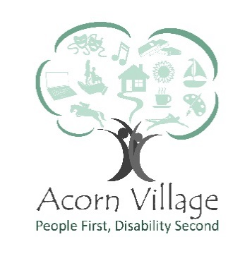
Role Description – Books/Vinyl Sorter
___________________________________________________________________________

Reports to: Retail Coordinator/Ecommerce Coordinator
Responsible for: Sorting of books/vinyl’s for resale through online/retail sites
Location: Acorn Village, Clacton Road, Mistley, Manningtree, Essex, CO11 2NJ
Role Purpose: Work alongside other volunteers to maximise sales and to provide a robust income stream for the Organisation
___________________________________________________________________________
Key Responsibilities
- Checking donated books/records
- Separating books for the charity shops, Ebay, World of Books, Music Magpie and other e-commerce outlets
- Researching the value of certain books/records for pricing
- Researching other online places to sell
- Volunteering under the supervision of the Retail Coordinator
- Understanding and adhering to the health and safety regulations of the organisation.
- Completing relevant training

Special Features of the Role
- Work as part of the Communication and Income Generation team to assist in achieving its financial goals

Personal Development
- All volunteers are encouraged to contribute to identifying and meeting their own role-related development needs. This will be achieved through a variety of processes including supervisions and team meetings
- Volunteers must attend statutory and mandatory training as required by the Organisation and/or our professional bodies

Key skills, experience and knowledge
- Good communication and interpersonal skills and a positive, can do attitude
- Appreciation for quality control standards and processes
- Creativity and willingness to learn
- Adaptable and flexible
- Keen eye to detail
- Able to plan and organise workload
- Able to work on own initiative and/or as part of a team
- Passion and drive to achieve results through increased sales
- Ability to maintain an awareness of current fashion trends and brands
- Good understanding of equality and diversity
- Willingness to undertake mandatory training

Training requirements
- Induction
- Health & Safety
- Fire Safety
- Moving and Handling

What you will gain from volunteering:
- An opportunity to be part of a friendly happy team
- Utilise and further your interests
- Opportunity to develop skills
- The satisfaction of the knowledge that you are making a vital difference to the lives of adults with a learning disability

Signed_________________________________
Name__________________________________
Date___________________________________

Acorn Village is committed to safeguarding and promoting the welfare of adults at risk and expects all staff to share this commitment.

Acorn Villages is an equal opportunities employer and welcomes applications from appropriately qualified people regardless of gender, marital status, sexual orientation, race, ethnic origin, colour, nationality, religion, disability or age.

