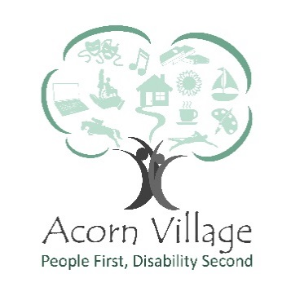
Role Description – E Commerce Volunteer
___________________________________________________________________________

Reports to: Ecommerce Coordinator
Responsible for: Researching values of donated goods, selling using online platforms, packaging sold items ready for posting/collection
Location: Acorn Village, Clacton Road, Mistley, Manningtree, Essex, CO11 2NJ
Role Purpose: Work alongside the Fundraising Team to maximise sales and to provide a robust income stream for the Organisation
___________________________________________________________________________
Key Responsibilities
- Research previous selling prices/values through a variety of sources to ascertain starting prices for listing
- Sorting and categorising items ready for listing
- Photographing items ensuring quality results that are clear and demonstrate condition
- Listing using appropriate online platforms
- Researching best postal services for price and quality of service
- Packaging sold goods
- Understanding and adhering to the health and safety regulations of the organisation.
- Completing relevant training
- Identify hazards, assess risks and report incidents as required

Special Features of the Role
- Work as part of the Communication and Income Generation team to assist in achieving its financial goals

Personal Development
- All volunteers are encouraged to contribute to identifying and meeting their own role-related development needs. This will be achieved through a variety of processes including supervisions and team meetings
- Volunteers must attend statutory and mandatory training as required by the Organisation and/or our professional bodies

Key skills, experience and knowledge
- A positive can do approach
- Willing to work independently or as part of a team
- A passion and skill set for effective online sales
- The desire to learn new skills or develop existing ones
- Basic IT skills are desired but not essential as training can be provided
- Previous knowledge of Ebay sales an advantage but is not essential as full training will be provided
- Good understanding of equality and diversity
- Willingness to undertake mandatory training

Training requirements
- Induction
- Health & Safety
- Fire safety
- Moving and Handling

What you will gain from volunteering:
- An opportunity to be part of a friendly happy team
- Utilise and further your interests in Ecommerce
- Opportunity to develop skills
- The satisfaction of the knowledge that you are making a vital difference to the lives of adults with a learning disability

Signed_________________________________

Name__________________________________

Date___________________________________

Acorn Village is committed to safeguarding and promoting the welfare of adults at risk and expects all staff to share this commitment.
Acorn Villages is an equal opportunities employer and welcomes applications from appropriately qualified people regardless of gender, marital status, sexual orientation, race, ethnic origin, colour, nationality, religion, disability or age.

