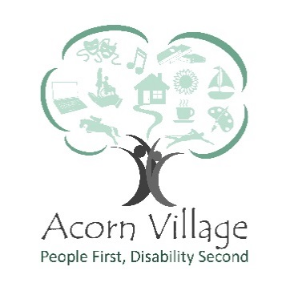
Role Description – Day Services Centre
___________________________________________________________________________

Reports to: Day Services Manager
Responsible for: Providing support and facilitating various sessions (gardening, cookery, arts, crafts, drama, media, IT)
Location: Day Services Centre, Acorn Village, Clacton Road, Mistley, Manningtree, Essex, CO11 2NJ
Role Purpose: Work alongside the Day Services Manager and team in a creative environment. To assist in supporting adults with a learning disability to learn new skills
___________________________________________________________________________
Key Responsibilities
- Participate in the co-ordination and preparation of workshops
- Cleaning and returning materials to storage at the end of each session
- Support outdoor/offsite activities
- Offering new ideas
- Assisting and supporting fund raising events
- Understanding and adhering to the health and safety regulations of the organisation.
- Completing relevant training
- Identify hazards, assess risks and report incidents as required

Special Features of the Role
- Work as part of the Day Services Centre Team to assist in achieving its financial goals

Personal Development
- All volunteers are encouraged to contribute to identifying and meeting their own role-related development needs. This will be achieved through a variety of processes including supervisions and team meetings
- Volunteers must attend statutory and mandatory training as required by the Organisation and/or our professional bodies

Key skills, experience and knowledge
- High level of organisational skills, problem solving and an eye for detail
- Excellent communication and interpersonal skills
- Keen interest in arts, crafts and working with adults with a learning disability
- A positive attitude
- Patient and empathic approach
- Good understanding of equality and diversity
- Willingness to undertake mandatory training

Training requirement
- Induction
- Health & Safety
- Fire safety
- Moving and Handling

What you will gain from volunteering:
- An opportunity to be part of a friendly happy team
- Utilise and further your interests
- Opportunity to develop skills
- The satisfaction of the knowledge that you are making a vital difference to the lives of adults with a learning disability

Signed_________________________________
Name__________________________________
Date___________________________________

Acorn Village is committed to safeguarding and promoting the welfare of adults at risk and expects all staff to share this commitment.
Acorn Villages is an equal opportunities employer and welcomes applications from appropriately qualified people regardless of gender, marital status, sexual orientation, race, ethnic origin, colour, nationality, religion, disability or age.

